

DATA INTERPRETATION USING POWER BI

A PROJECT REPORT

Submitted by

AJMAL AHAMED J | 2303811714821003
MIDHUN SHAGAR M G | 2303811714821015
PRASANNA I | 2303811714821030
VIMAL AANANTH B R | 2303811714821058
VISVAJEET R S | 2303811714821059

in partial fulfillment of the requirements for the award of the course

AMC1383 - DATA INTERPRETATION USING POWER BI

DEPARTMENT OF CSE (ARTIFICIAL INTELLIGENCE AND MACHINE LEARNING)
K. RAMAKRISHNAN COLLEGE OF TECHNOLOGY (AUTONOMOUS)
SAMAYAPURAM- 621112

MAY 2026



DATA INTERPRETATION USING POWER BI

A PROJECT REPORT

Submitted by

AJMAL AHAMED J | 2303811714821003
MIDHUN SHAGAR M G | 2303811714821015
PRASANNA I | 2303811714821030
VIMAL AANANTH B R | 2303811714821058
VISVAJEET R S | 2303811714821059

in partial fulfillment of the requirements for the award of the course

AMC1383 - DATA INTERPRETATION USING POWER BI

DEPARTMENT OF CSE (ARTIFICIAL INTELLIGENCE AND MACHINE LEARNING)
K. RAMAKRISHNAN COLLEGE OF TECHNOLOGY (AUTONOMOUS)
SAMAYAPURAM- 621112

MAY 2026

K. RAMAKRISHNAN COLLEGE OF TECHNOLOGY (AUTONOMOUS)
SAMAYAPURAM- 621112

BONAFIDE CERTIFICATE

The work embodied in the present project report entitled “DATA INTERPRETATION USING POWER BI” has been carried out by the students AJMAL AHAMED J, MIDHUN SHAGAR M G, PRASANNA I, VIMAL
AANANTH B R, VISVAJEET R S. The work reported here in is original and we declare that the project is their own work, except where specifically acknowledged, and has not been copied from other sources or been previously submitted for assessment.
Date of Viva Voce: ……………………

Dr. G. SATHISH KUMAR M.E., Ph.D.
SUPERVISOR
Assistant Professor Department of Mechanical Engineering
K. Ramakrishnan College of Technology (Autonomous) Samayapuram – 621 112
Dr. T. AVUDAIAPPAN M.E., Ph.D.
HEAD OF THE DEPARTMENT
Professor
Department of Artificial Intelligence
K. Ramakrishnan College of Technology (Autonomous) Samayapuram – 621 112

INTERNAL EXAMINER EXTERNAL EXAMINER
ii

ACKNOWLEDGEMENT

We thank our Dr. N. Vasudevan Principal, for his valuable suggestions and support during the course of our project work.
We thank our Dr. T. Avudaiappan M.E., Ph.D. Head of the Department, Professor, Department of Artificial Intelligence for his valuable suggestions and support during the course of our project work.
We wish to record our deep sense of gratitude and profound thanks to our Guide Mr. K. Rajaguru M.Tech., Ph.D. Assistant Professor, IQAC – HEAD for his keen interest, inspiring guidance, constant encouragement with our work during all stages, to bring this project into fruition.
We are extremely indebted to our project coordinators Dr. G. Sathish Kumar M.Tech., Ph.D. Assistant Professor, Department of Mechanical Engineering and Mr. P. B. Aravind Prasad M.Tech. Assistant Professor, Department of Artificial Intelligence, for his valuable suggestions and support during the course of our project work.
We also thank the faculty and non-teaching staff members of the Artificial Intelligence,
K. Ramakrishnan College of Technology (Autonomous), Samayapuram for their valuable support throughout the course of our project work.
Finally, we thank our parents, friends and our well wishes for their kind support.

SIGNATURE

AJMAL AHAMED J

MIDHUN SHAGAR M G

PRASANNA I

VIMALAANANTH BR

VISVAJEET R S
iii

ABSTRACT

In educational institutions, a large amount of student data is generated through various internal and external assessments. Analyzing this data manually is time- consuming, complex, and often leads to errors. The data used in this project is obtained from a REST API and loaded into Power BI using Power Query. The dataset includes student information, course details, and multiple assessment components. A customized data connection method is implemented to efficiently retrieve large volumes of data. Several data transformation steps are performed to prepare the dataset for analysis. These include changing data types, handling missing values, filtering relevant records, and standardizing column names to ensure consistency and clarity. These preprocessing steps help in organizing the data into a structured format suitable for analysis. The processed data is then used to create interactive dashboards in Power BI. These dashboards provide meaningful insights into student performance by enabling comparison, trend analysis, and evaluation of academic outcomes. Users can interact with the visuals to explore the data dynamically. Overall, this project demonstrates how Power BI can be effectively used to convert raw academic data into useful insights. It provides a simple and efficient approach for analyzing student performance and supports better decision-making in educational institutions.
Keywords : Power BI, Student Performance Analysis, Data Visualization, REST API, Power Query, Data Transformation, Interactive Dashboards, Data Preprocessing, Educational Analytics, Data-Driven Decision Making

TABLE OF CONTENTS

CHAPTER | TITLE | PAGE NO.
 | ABSTRACT | iv
 | LIST OF FIGURES | viii
 | LIST OF ABBREVIATIONS | ix
1 | INTRODUCTION | 1
 | 1.1 OVERVIEW | 1
 | 1.2 OBJECTIVE | 2
2 | LITERATURE SURVEY | 3

  - DATA VISUALIZATION USING POWER BI 3
  - POWER BI FOR DATA ANALYTICS AND
DECISION MAKING 4
  - DATA PREPROCESSING AND
TRANSFORMATION 5
  - ACADEMIC PERFORMANCE ANALYSIS
USING DATA ANALYTICS 6
  - DASHBOARD BASED DATA ANALYSIS SYSTEMS 7

3 | SYSTEM ANALYSIS | 8
 | 3.1 EXISTING SYSTEM | 8
 | 3.1.1 DEMERITS | 8
 | 3.2 PROPOSED SYSTEM | 9
 | 3.2.1 MERITS | 9

- SYSTEM SPECIFICATION 10
  - SYSTEM ENVIRONMENT 10
  - TOOLS & DATA SOURCE 10
- SYSTEM DESIGN 11
  - SYSTEM ARCHITECTURE 11
- MODULE DESCRIPTION 13
  - METHODOLOGY 13
  - DATA ACQUISITION MODULE 14
  - DATA PROCESSING MODULE 15
  - DATA VISUALIZATION MODULE 16
  - REPORTING MODULE 17
- ADVANCED ANALYSIS USING POWER BI 18
7.1 ADVANCED DATA MODELING 18
7.2 KPI (KEY PERFORMANCE INDICATOR) ANALYSIS 18
7.3 TREND ANALYSIS 19
7.4 COMPARATIVE ANALYSIS 19
7.5 DRILL-DOWN AND INTERACTIVE ANALYSIS 20
- CHALLENGES AND LIMITATIONS 21
8.1 DATA QUALITY ISSUES 21
8.2 API INTEGRATION CHALLENGES 21

8.3 PERFORMANCE LIMITATIONS 21
8.4 DASHBOARD DESIGN COMPLEXITY 22
8.5 USER UNDERSTANDING AND TRAINING 22
- RESULT AND DISCUSSION 23
- CONCLUSION AND FUTURE ENHANCEMENT 25
  - CONCLUSION 25
  - FUTURE ENHANCEMENT 26
APPENDIX A SCREENSHOTS 27
REFERENCES 30

LIST OF FIGURES

FIGURE NO. | TITLE | PAGE NO.
5.1 | System Architecture | 12
A.1 | Data Preview 1 | 27
A.2 | Data Preview 2 | 27
A.3 | Sample Dashboard 1 | 28
A.4 | Sample Dashboard 2 | 28
A.5 | Sample Dashboard 3 | 29
A.6 | Sample Dashboard 4 | 29

LIST OF ABBREVIATIONS

BI – Business Intelligence

API – Application Programming Interface

JSON – JavaScript Object Notation

DAX – Data Analysis Expressions

ETL – Extract, Transform, Load

KPI – Key Performance Indicator

DBMS – Database Management System

UI – User Interface

UX – User Experience

CSV – Comma Separated Values

XML – Extensible Markup Language

IT – Information Technology

AI – Artificial Intelligence

ML – Machine Learning

CHAPTER 1 INTRODUCTION
  - OVERVIEW
In educational institutions, a large volume of student data is generated through various academic activities such as internal assessments, laboratory evaluations, assignments, and model examinations. Managing and analyzing this data manually is a complex and time-consuming process. Traditional methods often involve spreadsheets or manual calculations, which may lead to errors and make it difficult to identify performance trends clearly. With the advancement of technology, data analytics and visualization tools have become essential for handling large datasets efficiently. Microsoft Power BI is a powerful business intelligence tool that enables users to collect, transform, and analyze data in an effective manner. It provides features such as data cleaning, filtering, and interactive visualization, which help in converting raw data into meaningful insights.
In this project, student marks data is obtained from an external data source and loaded into Power BI using Power Query. The dataset includes student details, course information, and assessment data. Since raw data may contain inconsistencies or missing values, several preprocessing steps are applied. These include changing data types, filtering required data, handling missing values, and organizing the dataset into a structured format suitable for analysis. The processed data is then used to create interactive dashboards in Power BI. These dashboards help in analyzing student performance, comparing results, and identifying trends across different assessments. Users can interact with the visuals to explore the data dynamically, making the analysis more flexible and easy to understand.
Overall, this project provides an efficient approach for analyzing academic data and generating useful insights. It supports better understanding of student performance and helps educational institutions make informed decisions based on data.

  - OBJECTIVE

The main objective of this project is to analyze student academic performance using Microsoft Power BI and to present the data in a meaningful and visually understandable format. The project focuses on transforming raw academic data into structured information that can support effective analysis and decision- making. One of the primary objectives is to collect student marks data from an external data source and load it into Power BI using Power Query. This involves establishing a proper data connection and ensuring that the data is retrieved accurately. Another important objective is to perform data cleaning and transformation. Since raw data may contain inconsistencies, missing values, or unstructured formats, it is necessary to preprocess the data by applying techniques such as changing data types, filtering relevant records, and organizing the dataset.
The project also aims to standardize the data structure to improve clarity and consistency. Proper organization of data makes it easier to perform analysis and reduces confusion during interpretation. In addition, the project focuses on analyzing student performance across different assessments to understand overall academic progress. Another key objective is to create interactive dashboards using Power BI. These dashboards help in visualizing the data through charts, tables, and filters, making it easier to identify trends and compare results. The interactive features allow users to explore the data dynamically and gain deeper insights.
Finally, the project aims to support data-driven decision-making in educational institutions. By providing clear and meaningful insights, the system helps in identifying strengths and areas for improvement among students. Overall, the objective of this project is to develop a simple, efficient, and user-friendly system for analyzing student performance using Power BI.

CHAPTER 2 LITERATURE SURVEY
  - DATA VISUALIZATION USING POWER BI

Zamil, M. H., Mohiuddin, M., & Mamun, M. N. H. Published Year: 2024
This study discusses the use of business intelligence tools such as Microsoft Power BI for data visualization and analysis. It explains how Power BI transforms raw data into meaningful insights through interactive dashboards. The study highlights that Power BI supports multiple data sources and helps in identifying trends and patterns. It concludes that data visualization tools improve data accessibility and support better decision-making.

Merits

    - Provides interactive dashboards
    - Helps in identifying trends and patterns
    - Supports multiple data sources
    - Improves decision-making

Demerits

    - Requires data preprocessing
    - Depends on data quality
    - Needs basic technical knowledge

  - POWER BI FOR DATA ANALYTICS AND DECISION MAKING

Kumaresan Durvas Jayaraman et al. Published Year: 2025
This study focuses on the use of Microsoft Power BI for data analytics and decision-making. It explains how Power BI collects data from multiple sources and presents it through interactive dashboards. The study highlights that Power BI helps in analyzing large datasets, identifying trends, and improving decision-making. It also supports real-time data analysis and easy sharing of reports. The tool provides a user-friendly interface that simplifies data interpretation. It enables users to explore data visually and gain better insights. These features make it suitable for handling complex datasets efficiently.

Merits

    - Helps in identifying trends and patterns
    - Supports interactive dashboards
    - Improves decision-making
    - Enables easy sharing of reports

Demerits

    - Requires data preprocessing
    - Depends on data quality
    - Needs basic technical knowledge

  - DATA PREPROCESSING AND TRANSFORMATION

Kotu, V., & Deshpande, B. Published Year: 2024
This study highlights the importance of data preprocessing in data analysis. It explains that raw data often contains missing values, inconsistencies, and unstructured formats, which can affect the accuracy of results. Data preprocessing helps in cleaning and preparing the data for further analysis. The study explains that transformation techniques such as changing data types, filtering, and organizing data improve data quality. It also helps in creating a structured dataset suitable for visualization and analysis. Proper preprocessing ensures reliable results and reduces errors. These steps are essential before performing any data analysis.

Merits

    - Improves data quality and accuracy
    - Helps in organizing data effectively
    - Reduces errors in analysis
    - Makes data suitable for visualization

Demerits

    - Time-consuming process
    - Requires careful data handling
    - May need technical knowledge

  - ACADEMIC PERFORMANCE ANALYSIS USING DATA ANALYTICS

Papamitsiou, Z., & Economides, A. A. Published Year: 2024
This study focuses on analyzing student academic performance using data analytics techniques. It explains how educational data can be used to evaluate student progress and identify learning patterns. The analysis helps in understanding performance variations across different assessments. The study highlights that data analytics enables institutions to track student performance and identify areas that require improvement. It also supports comparison of results and helps in recognizing trends over time. The use of analytical tools improves accuracy and reduces manual effort. These methods support better academic planning and decision-making.

Merits

    - Helps in analyzing student performance effectively
    - Identifies trends and learning patterns
    - Supports better academic planning
    - Reduces manual analysis effort

Demerits

    - Depends on data accuracy
    - Requires proper data management
    - May need technical expertise

  - DASHBOARD-BASED DATA ANALYSIS SYSTEMS

Few, S.

Published Year: 2024

This study discusses the use of dashboards in data analysis systems for presenting information in a visual and interactive format. It explains how dashboards combine multiple visual elements such as charts and tables to provide a clear overview of data. Dashboards help users monitor key performance indicators and understand data quickly. The study highlights that interactive dashboards allow users to filter and explore data easily. It improves data accessibility and supports faster decision-making. Dashboards also reduce the complexity of large datasets by presenting them in a simplified manner. These features make dashboard systems useful in various domains including education.

Merits

    - Provides clear and visual representation of data
    - Enables interactive data exploration
    - Supports quick decision-making
    - Simplifies complex datasets

Demerits

    - Requires proper dashboard design
    - May lead to misinterpretation if poorly designed
    - Depends on data quality

CHAPTER 3 SYSTEM ANALYSIS
  - EXISTING SYSTEM

In many educational institutions, student performance data is maintained using traditional methods such as spreadsheets or manual records. These systems are primarily used for storing marks and basic calculations, but they lack advanced analytical capabilities. As a result, it becomes difficult to analyze large volumes of data and extract meaningful insights. The existing system does not support proper visualization techniques, making it hard to identify trends, compare performance, or track student progress effectively. Data analysis is often done manually, which increases the chances of errors and consumes more time. Additionally, these systems do not provide interactive features for exploring data dynamically.
Due to the lack of automation and visualization, the existing system is not efficient for modern data analysis requirements. It fails to support data-driven decision- making and limits the ability of institutions to improve academic performance effectively.

Demerits

      - No real-time monitoring of energy consumption
      - Time-consuming manual data analysis
      - Higher chances of human errors
      - Lack of proper data visualization
      - Difficult to identify trends and patterns
      - No interactive analysis features
      - Not suitable for large datasets

  - PROPOSED SYSTEM

The proposed system introduces a data analysis solution using Microsoft Power BI to overcome the limitations of the existing system. It focuses on transforming raw student data into meaningful insights through data visualization and interactive dashboards.
In this system, data is collected from an external source and processed using Power Query. Various data transformation steps are applied to clean and structure the dataset. The processed data is then used to create interactive dashboards that allow users to analyze student performance effectively.
The system provides features such as filtering, comparison, and trend analysis, which help in understanding academic performance more clearly. It enables users to explore data dynamically and supports better decision-making. Overall, the proposed system provides an efficient, accurate, and user-friendly approach for analyzing student data using modern data visualization tools.

Merits

      - Provides interactive data visualization
      - Reduces manual effort and errors
      - Helps in identifying trends and patterns
      - Supports efficient data analysis
      - Enables better decision-making
      - Suitable for large datasets

CHAPTER 4 SYSTEM SPECIFICATION

SYSTEM ENVIRONMENT

The system environment required for this project consists of a standard computer or laptop capable of running data analysis tools efficiently. The project is developed using Microsoft Power BI, which requires a system with sufficient processing capability and memory. A system with a minimum of 4 GB RAM and a modern processor is required for basic operations. For better performance, especially when handling large datasets, 8 GB RAM or higher is recommended. Adequate storage space is also necessary to store datasets and reports.
The system should operate on Windows 10 or later to ensure compatibility with Power BI Desktop. A stable internet connection is required for fetching data from external sources and updating reports. This environment supports smooth data processing and visualization.

TOOLS & DATA SOURCE

The main tool used in this project is Microsoft Power BI Desktop, which is used for data analysis and visualization. It provides features such as data transformation, modeling, and dashboard creation. Power Query is used for data cleaning and preprocessing, including handling missing values and structuring the dataset. DAX is used to create calculations and measures required for analysis.
The data is obtained from an external API in JSON format, which includes student details and assessment data. This data is imported into Power BI and processed to create interactive dashboards. These tools enable efficient analysis and visualization of student performance data.

CHAPTER 5 SYSTEM DESIGN

SYSTEM ARCHITECTURE

The system architecture represents the overall structure of the student mark analysis system developed using Microsoft Power BI. It defines how data is collected, processed, and visualized to generate meaningful insights. The system begins with the data acquisition stage, where student marks data is obtained from an external API. The data is received in a structured format and includes student details, course information, and assessment records. This data serves as the input for further processing.
In the next stage, the data is imported into Power BI using Power Query. Data transformation processes such as cleaning, filtering, and structuring are applied to ensure the dataset is accurate and suitable for analysis. These steps help in organizing the data and removing inconsistencies. After preprocessing, the data is used for analysis and visualization. Various charts, tables, and filters are created to represent student performance clearly.
The system allows users to interact with the data through dashboards, enabling them to explore trends and compare results effectively. Finally, the output is presented through interactive dashboards that provide insights into academic performance. The system architecture ensures a smooth flow of data from collection to visualization, making the analysis process efficient and user-friendly.
The system flow describes the step-by-step process involved in analyzing student data using Power BI. The process starts with collecting data from an external source. The data is then loaded into Power BI for further processing. Next, data transformation is performed using Power Query, where unnecessary data is removed and required data is structured properly.

After preprocessing, the data is analyzed and visualized using different charts and dashboards. The final step involves presenting the results through interactive dashboards. Users can apply filters and explore the data dynamically. This flow ensures that the system operates efficiently from data collection to visualization.
Finally, the output is presented through interactive dashboards that provide insights into academic performance. The system architecture ensures a smooth flow of data from collection to visualization, making the analysis process efficient and user- friendly.
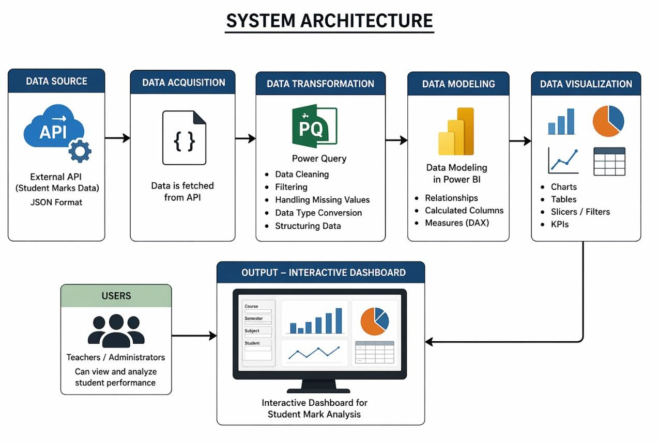

Figure.5.1 System Architecture

CHAPTER 6 MODULE DESCRIPTION

METHODOLOGY
The methodology of this project is designed to provide a structured approach for analyzing student academic performance using Microsoft Power BI. It involves multiple stages, starting from data collection to final visualization and interpretation of results. Each stage plays a crucial role in ensuring that the data is accurate, meaningful, and suitable for analysis. The first step in the methodology is data acquisition. The required data is obtained from an external API, which provides student marks information in a structured format. This data includes details such as student information, course details, and assessment records. The data is then imported into Power BI using Power Query, which allows seamless integration with external data sources. Once the data is loaded, the next step is data preprocessing. Raw data often contains missing values, inconsistencies, or unnecessary information. To address this, various data transformation techniques are applied. These include filtering irrelevant data, handling missing values, converting data types, and organizing the dataset into a structured format. This step ensures that the dataset is clean, consistent, and ready for analysis.
After preprocessing, the data is used for analysis and visualization. Power BI provides various tools to create charts, tables, and dashboards that represent the data visually. These visualizations help in understanding student performance, identifying trends, and comparing results across different assessments. Interactive features such as filters and slicers allow users to explore the data dynamically. Finally, the results are presented through dashboards, which provide a clear and comprehensive view of the analysis. These dashboards help users interpret the data easily and support better decision-making. The methodology ensures a smooth and efficient workflow from data collection to final output, making the system effective and user-friendly.

DATA ACQUISITION MODULE

The data acquisition module is the first and most important component of the system, as it is responsible for collecting the required student data for analysis. In this project, the data is obtained from an external API, which provides student marks information in a structured format. The dataset includes details such as student information, course details, and various assessment records.
The API serves as a reliable data source, allowing real-time or updated data to be fetched whenever required. The data is typically received in JSON format, which is widely used for data exchange due to its simplicity and compatibility with modern applications. This structured format makes it easier to import and process the data within Power BI.
Microsoft Power BI uses Power Query to connect to the API and retrieve the data. Power Query provides built-in features for establishing connections with external data sources, including APIs. By configuring the connection parameters, the system can fetch data efficiently and load it into the Power BI environment. This process ensures that the data is available for further transformation and analysis.
The data acquisition module also ensures that the data is collected accurately and consistently. It handles large volumes of data by retrieving it in an organized manner, which helps in maintaining data integrity. Proper data acquisition is essential, as any issues at this stage can affect the entire analysis process.
Overall, the data acquisition module forms the foundation of the system. It ensures that reliable and relevant data is collected from the source and made available for preprocessing and analysis. This module plays a crucial role in enabling the system to generate accurate and meaningful insights.

DATA PROCESSING MODULE

The data processing module plays a crucial role in converting raw data into a clean and structured format suitable for analysis. After the data is acquired from the external API, it may contain inconsistencies such as missing values, incorrect data types, duplicate entries, or irrelevant information. This module focuses on handling such issues to ensure the quality and reliability of the dataset.
In this project, data processing is performed using Power Query in Microsoft Power BI. Power Query provides various tools and functions to transform and clean the data efficiently. The first step in this module involves examining the dataset to identify any inconsistencies or errors. Based on this analysis, appropriate transformation steps are applied.
One of the key tasks in data processing is handling missing values. Missing or null values can affect the accuracy of analysis, so they are either replaced, removed, or managed using suitable techniques. Another important step is converting data types, such as changing text values to numerical or date formats, to ensure proper calculations and analysis.
Filtering is also applied to remove unnecessary or irrelevant data from the dataset. This helps in reducing complexity and improving performance. Additionally, columns are organized and renamed to maintain consistency and improve readability. These steps make the dataset more structured and easier to work with.
The data processing module ensures that the dataset is accurate, consistent, and ready for visualization. Proper data processing improves the overall quality of analysis and helps in generating meaningful insights. Without this step, the results may be misleading or incorrect. Therefore, this module is essential for the success of the entire system.

DATA VISUALIZATION MODULE

The data visualization module is responsible for presenting the processed data in a graphical and interactive format. This module plays a key role in converting complex datasets into easily understandable visual representations. In this project, Microsoft Power BI is used to create various visual elements such as charts, tables, and dashboards that help in analyzing student performance effectively.
After the data is cleaned and structured in the previous stages, it is used to generate visualizations. Power BI provides a wide range of visualization options including bar charts, line charts, pie charts, and tables. These visual elements help in comparing student performance, identifying trends, and understanding overall academic progress. By representing data visually, users can quickly interpret information without going through large tables of raw data.
One of the important features of this module is interactivity. Power BI allows users to interact with the data using filters, slicers, and drill-down options. This enables users to explore the data dynamically by focusing on specific subjects, students, or assessment components. Interactivity makes the analysis more flexible and user- friendly, allowing deeper insights into the dataset. The visualization module also focuses on designing dashboards that present information in a clear and organized manner. A well-designed dashboard provides a summary of key insights and helps users understand the overall performance at a glance. Proper selection of charts and layout ensures that the information is presented effectively without confusion.
Overall, the data visualization module enhances the understanding of data by presenting it in a meaningful and interactive way. It helps users identify patterns, compare results, and make informed decisions. This module is essential for transforming processed data into valuable insights.

REPORTING MODULE

The reporting module is the final stage of the system, where the analyzed data is presented in the form of reports and dashboards. This module focuses on delivering the results of the data analysis in a clear, structured, and user- friendly manner. In this project, Microsoft Power BI is used to create interactive reports that provide insights into student performance.
After the data has been processed and visualized, the results are organized into dashboards that summarize key information. These dashboards include various visual elements such as charts, tables, and filters, which help in presenting the data effectively. The reports are designed in a way that users can easily understand the performance of students across different assessments.
One of the important features of the reporting module is interactivity. Users can apply filters, select specific data points, and explore the information dynamically. This allows users to focus on particular students, subjects, or performance levels. Interactive reports provide flexibility and enable deeper analysis without the need for complex operations.
The reporting module also ensures that the information is presented in a meaningful way. Proper layout, clear labeling, and appropriate visualization techniques are used to avoid confusion and improve readability. This helps users interpret the data accurately and make informed decisions.
Overall, the reporting module provides a comprehensive view of the analysis results. It helps in communicating insights effectively and supports data-driven decision- making. This module plays a crucial role in converting analyzed data into actionable information for educational institutions.

CHAPTER 7
ADVANCED ANALYSIS USING POWER BI
7.1 ADVANCED DATA MODELING
Advanced data modeling plays a crucial role in improving the efficiency and performance of data analysis systems. In this project, relationships between different tables such as student details, course information, and assessment data are established to create a structured data model. These relationships help in connecting multiple datasets and enable seamless analysis across different dimensions. Power BI provides features such as star schema modeling, which improves query performance and simplifies data interpretation. The use of calculated columns and measures enhances the analytical capabilities of the system. DAX (Data Analysis Expressions) is used to create complex calculations such as pass percentage, average marks, and performance indicators. These calculations allow users to derive meaningful insights from the data. Proper data modeling ensures that the system is scalable and capable of handling large datasets efficiently. It also reduces redundancy and improves data consistency. Overall, advanced data modeling helps in building a strong foundation for analysis. It enables faster data processing, better visualization, and improved decision-making. This makes the system more efficient and reliable for academic performance analysis.
7.2 KPI (KEY PERFORMANCE INDICATOR) ANALYSIS
Key Performance Indicators (KPIs) are essential for evaluating student performance and measuring academic success. In this project, KPIs such as pass percentage, attendance percentage, average marks, and fail count are used to analyze student performance effectively. These indicators provide a quick overview of the overall academic status and help in identifying areas that need improvement.Power BI allows the creation of KPI visuals that display performance metrics clearly. These visuals highlight whether the performance is improving or declining over time.

By using KPIs, institutions can monitor student progress and take necessary actions to improve results. For example, low attendance or low pass percentage can be identified easily using KPI indicators. KPIs also help in comparing performance across different departments, courses, and semesters. This comparison enables better understanding of academic trends and supports data-driven decision-making. Overall, KPI analysis simplifies complex data and provides meaningful insights in an easy-to-understand format.
7.3 TREND ANALYSIS
Trend analysis is an important aspect of data analytics that helps in identifying patterns and changes over time. In this project, trend analysis is performed using line charts and time-based visualizations. These charts show how student performance changes across different semesters and academic years. By analyzing trends, institutions can understand whether performance is improving or declining. For example, an increase in pass percentage over time indicates better academic outcomes. Similarly, a decrease in attendance percentage may indicate issues that need attention. Trend analysis helps in identifying such patterns and supports proactive decision-making. Power BI provides interactive features that allow users to filter data and analyze trends for specific departments or courses. This flexibility enhances the depth of analysis and provides more accurate insights. Overall, trend analysis helps in understanding long-term performance and supports strategic planning in educational institutions.
7.4 COMPARATIVE ANALYSIS
Comparative analysis involves comparing student performance across different categories such as departments, courses, and assessments. This analysis helps in identifying strengths and weaknesses in academic performance. In this project, bar charts and tables are used to compare results effectively. For example, performance of different departments can be compared to identify which department has the highest pass percentage. Similarly, comparison between different subjects helps in understanding subject-wise performance. This analysis provides valuable insights that can be used to improve teaching methods and student outcomes.

Power BI allows dynamic comparison using filters and slicers. Users can select specific criteria and compare results instantly. This makes the analysis more flexible and user-friendly. Overall, comparative analysis enhances the understanding of data and supports better decision-making.
7.5 DRILL-DOWN AND INTERACTIVE ANALYSIS
Interactive analysis is one of the key features of Power BI. It allows users to explore data in detail using features such as drill-down, filters, and slicers. In this project, users can drill down from overall performance to individual student details. For example, a user can start by viewing department-level performance and then drill down to course-level or student-level data. This helps in understanding the data at different levels of detail. Interactive features make the analysis more engaging and allow users to explore data based on their requirements. Drill-down functionality improves data exploration and helps in identifying specific issues. It enables users to focus on particular data points and gain deeper insights. Overall, interactive analysis enhances the usability of the system and makes data interpretation easier.

CHAPTER 8

CHALLENGES AND LIMITATIONS

8.1 DATA QUALITY ISSUES
One of the major challenges faced in this project is related to data quality. The data obtained from external sources may contain missing values, duplicate entries, or incorrect information. These issues can affect the accuracy of analysis and lead to misleading results.
To overcome this challenge, data preprocessing techniques are applied. However, ensuring complete data accuracy is still difficult. Proper validation and cleaning are required to maintain data quality. This highlights the importance of reliable data sources for accurate analysis.
8.2 API INTEGRATION CHALLENGES
Integrating data from APIs can be complex due to authentication issues, data structure variations, and network dependencies. In this project, data is fetched from a REST API, which requires proper configuration and handling.
Sometimes, API responses may change or fail, which affects data retrieval. Handling large volumes of data through APIs also requires efficient methods. These challenges make API integration a critical part of the system.
8.3 PERFORMANCE LIMITATIONS
Handling large datasets in Power BI may affect performance. Slow loading time and delayed visual updates can impact user experience. Proper data modeling and optimization techniques are required to improve performance.
Techniques such as filtering unnecessary data, reducing columns, and optimizing DAX calculations help in improving performance. However, performance limitations still exist when dealing with very large datasets.

8.4 DASHBOARD DESIGN COMPLEXITY
Designing effective dashboards requires careful planning. Poor design may lead to confusion and misinterpretation of data. Selecting appropriate charts and layout is essential for clear visualization. In this project, efforts are made to design user-friendly dashboards. However, designing an optimal dashboard that meets all requirements is a challenging task. Continuous improvements are required to enhance dashboard usability.
8.5 USER UNDERSTANDING AND TRAINING
Users may require basic knowledge of Power BI to interact with dashboards effectively. Without proper understanding, users may find it difficult to interpret data correctly. Providing training and documentation can help users understand the system better. This ensures that the dashboards are used effectively for decision-making.

CHAPTER 9

RESULT AND DISCUSSION

The result and discussion section presents the outcomes of the student mark analysis carried out using Microsoft Power BI. The system was successfully implemented to process, analyze, and visualize student data obtained from an external data source. The data was transformed into a structured format and presented through interactive dashboards, which made it easier to interpret and understand.
The results indicate that the system is capable of effectively analyzing student performance across different assessments. Various visual elements such as charts, tables, and filters were used to represent the data in a clear and meaningful way. These visualizations helped in identifying patterns, comparing student performance, and understanding overall academic progress. The dashboards provide a comprehensive view of the data, enabling users to quickly analyze results without manually examining large datasets.
One of the key observations from the results is that data visualization significantly improves the understanding of complex information. Instead of relying on traditional tabular data, graphical representations allow users to interpret results more efficiently. The use of interactive features such as slicers and filters enables users to explore specific data points, such as individual student performance or subject-wise analysis. This flexibility enhances the overall analysis process and provides deeper insights into the dataset. The system also demonstrates good performance in handling and processing data. Power Query is effectively used for data transformation, ensuring that the dataset is clean and consistent.
The integration of data processing and visualization tools allows for accurate and reliable results. The dashboards respond efficiently to user interactions, making the system user-friendly and easy to operate. During the analysis, it was observed that the system can help in identifying both strong and weak areas in student performance. It allows institutions to monitor progress, compare results across different assessments, and recognize trends over time. These insights can be used to improve teaching strategies and provide better academic support to students.

However, the system has certain limitations. The accuracy of the results depends on the quality of the input data. Any missing or incorrect data can affect the overall analysis. Therefore, proper data preprocessing is essential to ensure reliable results. Additionally, the effectiveness of the dashboards depends on proper design and selection of visual elements.
Overall, the project successfully demonstrates the use of Power BI for analyzing student data. The results show that the system is efficient, reliable, and capable of providing meaningful insights. It offers a practical solution for academic data analysis and supports data-driven decision-making in educational institutions.

CHAPTER 10

CONCLUSION AND FUTURE ENHANCEMENT

10.1 CONCLUSION

The project “DATA INTERPRETATION USING POWER BI” has
been successfully developed to analyze and visualize student academic performance in an efficient manner. The system effectively transforms raw student data into meaningful insights using data processing and visualization techniques.
The data collected from an external source was processed using Power Query to ensure accuracy and consistency. Various data transformation steps such as cleaning, filtering, and structuring were applied to prepare the dataset for analysis. The processed data was then visualized using interactive dashboards, which helped in understanding student performance clearly.
The results of the project demonstrate that data visualization plays a significant role in simplifying complex datasets. The use of charts, tables, and filters enables users to identify trends, compare results, and analyze performance effectively. The system provides a user-friendly interface that allows users to interact with the data and gain deeper insights.
This project also highlights the importance of data-driven decision-making in educational institutions. By analyzing student performance data, institutions can identify strengths and areas for improvement. It helps in improving academic planning and supports better decision-making.
Overall, the project achieves its objectives by providing a simple, efficient, and reliable system for student performance analysis. It demonstrates the practical application of Power BI in the field of education and shows how modern tools can enhance data analysis processes.

10.2 FUTURE ENHANCEMENT

Although the current system provides an effective solution for student data analysis, there are several areas where further improvements can be made. Future enhancements can focus on improving functionality, performance, and usability of the system.
One of the major enhancements is the integration of real-time data updates. By connecting the system to live databases, the dashboards can be updated automatically, providing up-to-date insights. This will improve the accuracy and usefulness of the analysis.
Another improvement can be the implementation of advanced analytics techniques such as predictive analysis. By using machine learning models, the system can predict student performance and identify potential risks. This will help institutions take proactive measures to improve academic outcomes.
The system can also be enhanced by developing web or mobile-based interfaces. This will allow users to access dashboards remotely and improve accessibility. Additional features such as automated reporting and notifications can further improve the usability of the system.
Moreover, the system can be extended to include more data sources such as attendance records and behavioral data. This will provide a more comprehensive analysis of student performance.
Overall, these enhancements will make the system more powerful, scalable, and suitable for real-world applications. They will improve the effectiveness of data analysis and support better decision-making in educational institutions.

APPENDIX A SCREENSHOTS
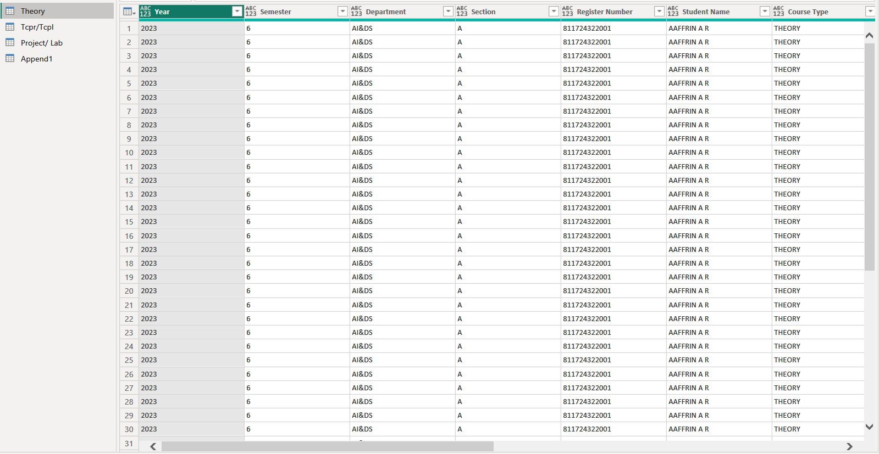

Figure.A.1 Data Preview 1

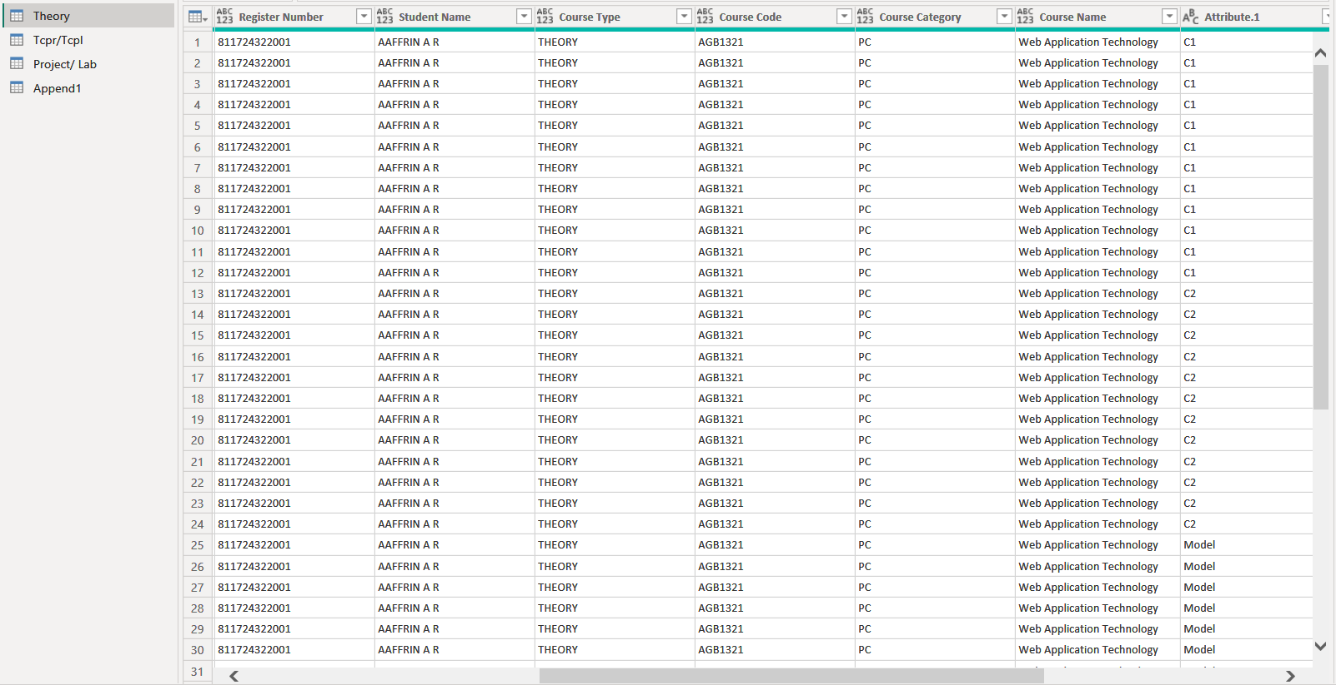

Figure.A.2 Data Preview 2

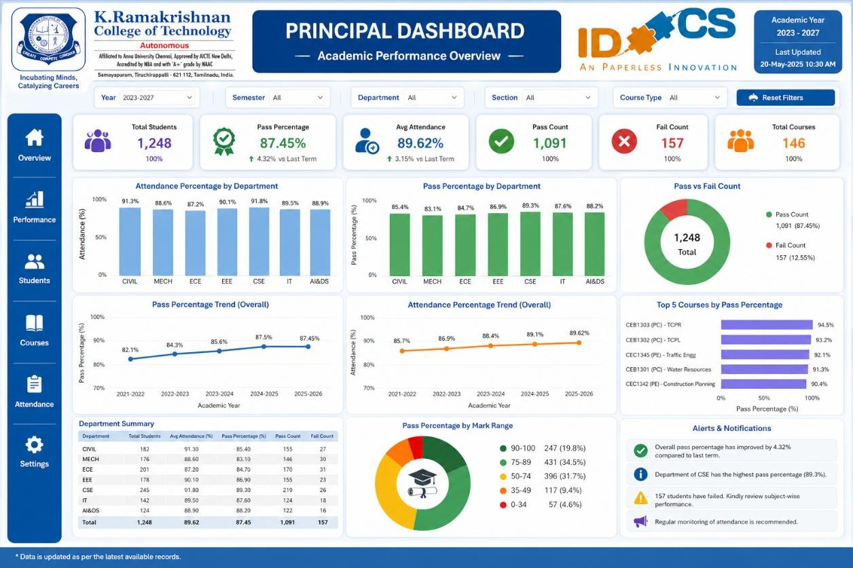

Figure.A.3 Sample Dashboard 1

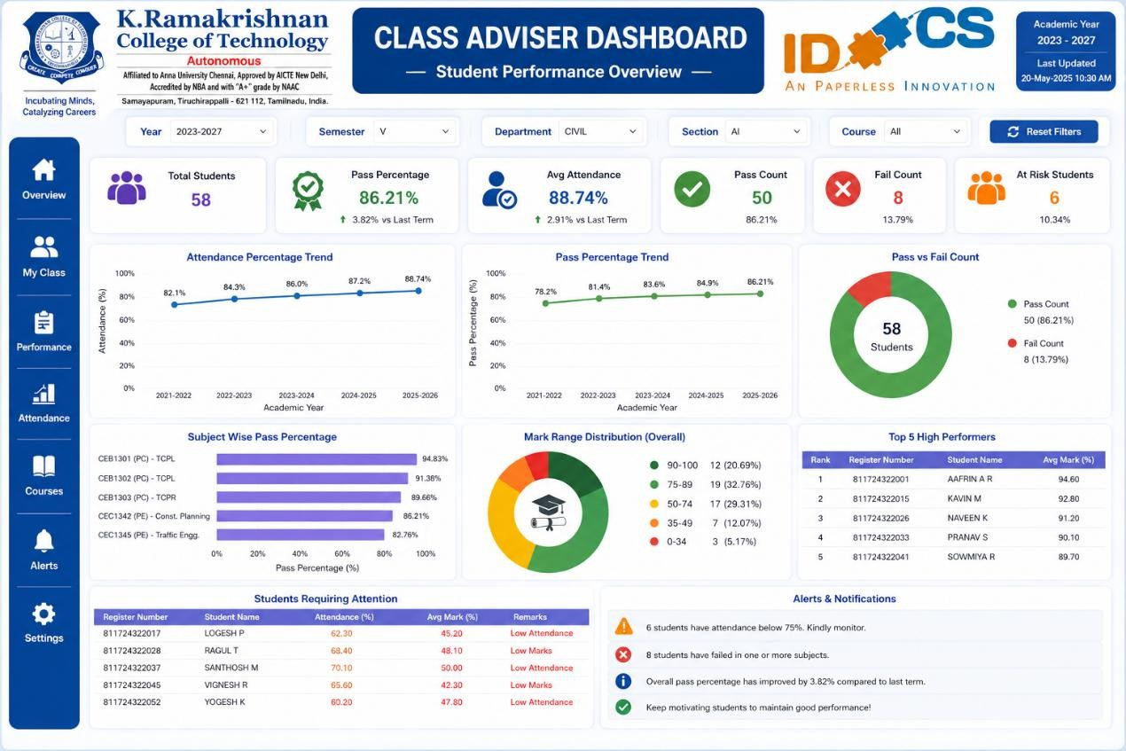

Figure.A.4 Sample Dashboard 2

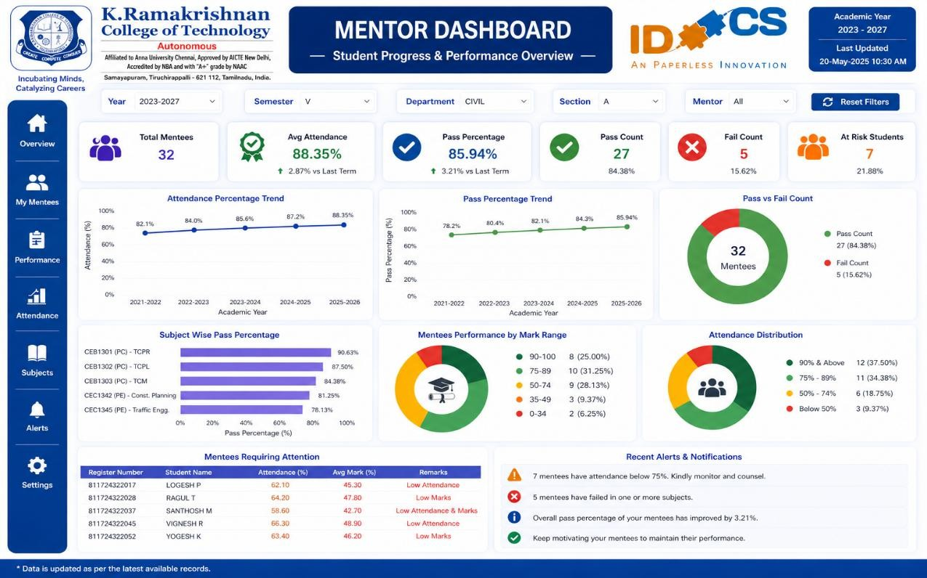

Figure.A.5 Sample Dashboard 3

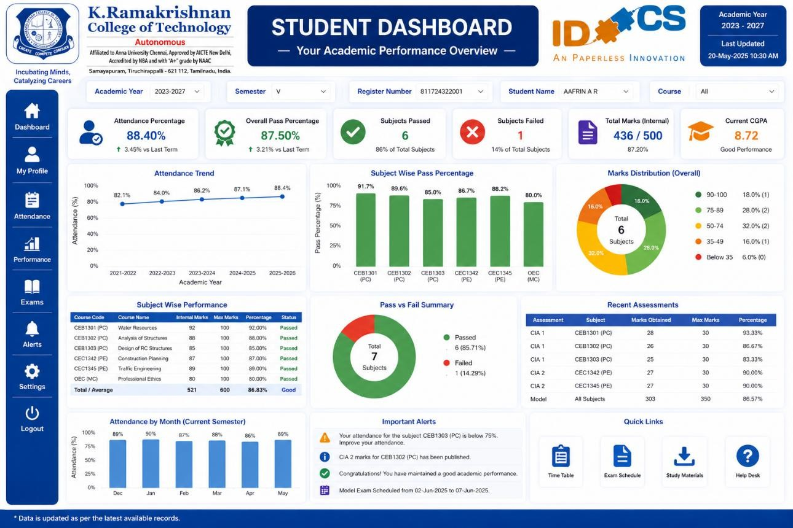

Figure.A.6 Sample Dashboard 4

REFERENCES

- Ahmed, M., & Hussain, R., “Data Analytics for Student Performance Evaluation Using Power BI,” International Journal of Data Science, 2025.
- Ali, S., Khan, T., & Rahman, M., “Interactive Dashboard Systems for Educational Data Analysis,” Journal of Information Systems, 2026.
- Brown, T., & Wilson, P., “Business Intelligence Tools for Data Visualization and Decision Making,” IEEE Access, 2024.
- Chen, L., & Zhang, Y., “Data-Driven Decision Making Using Visualization
Tools,” IEEE Transactions on Data Engineering, 2026.

- Das, H., & Banerjee, S., “Educational Data Mining and Student Performance Analysis,” International Journal of Computer Applications, 2024.
- Gupta, E., & Mishra, K., “Advanced Data Visualization Techniques Using Power BI,” Journal of Big Data Analytics, 2025.
- Iyer, R., & Nair, S., “Real-Time Data Processing Using Business
Intelligence Tools,” Journal of Cloud Computing, 2025.

- Jain, A., & Mehta, S., “Data Transformation Techniques in Power BI,”
International Journal of Data Engineering, 2024.

- Kumar, A., & Singh, R., “Student Performance Analysis Using Business Intelligence Tools,” International Journal of Educational Technology, 2025.
- Lee, J., Kim, H., & Park, S., “Big Data Analytics in Education Systems,”
IEEE Transactions on Learning Technologies, 2024.

- Menon, V., & Nair, G., “Dashboard-Based Data Analysis for Academic
Performance,” Journal of Information Technology, 2026.

- Patel, D., & Shah, N., “Data Visualization Methods for Large Datasets,”
International Journal of Advanced Computing, 2024.

- Reddy, C., & Rao, M., “Interactive Reporting Systems Using Power BI,”
Journal of Data Science and Analytics, 2025.

- Sharma, P., & Verma, K., “Business Intelligence Applications in Education Sector,” International Journal of Computer Science, 2026.
- Singh, P., & Kaur, R., “Data Preprocessing Techniques for Analytics,”
Journal of Data Mining and Knowledge Discovery, 2024.

- Thomas, I., & George, J., “Real-Time Dashboard Design and
Implementation,” International Journal of Software Engineering, 2025.

- Verma, L., & Gupta, R., “Analysis of Student Data Using Visualization Tools,” Journal of Educational Data Science, 2026.
- Wang, X., & Li, J., “Data Analytics and Visualization Using Power BI,”
IEEE Access, 2025.

- Zhang, Q., & Liu, L., “Modern Business Intelligence Systems for Data Analysis,” Journal of Artificial Intelligence Research, 2024.
- Zhou, H., & Chen, Y., “Efficient Data Processing and Visualization Techniques,” International Journal of Big Data Research, 2026.

